Computer Graphics

3rd Assignment

2014001321 박지호

1.

What I downloaded from <https://free3d.com/>

`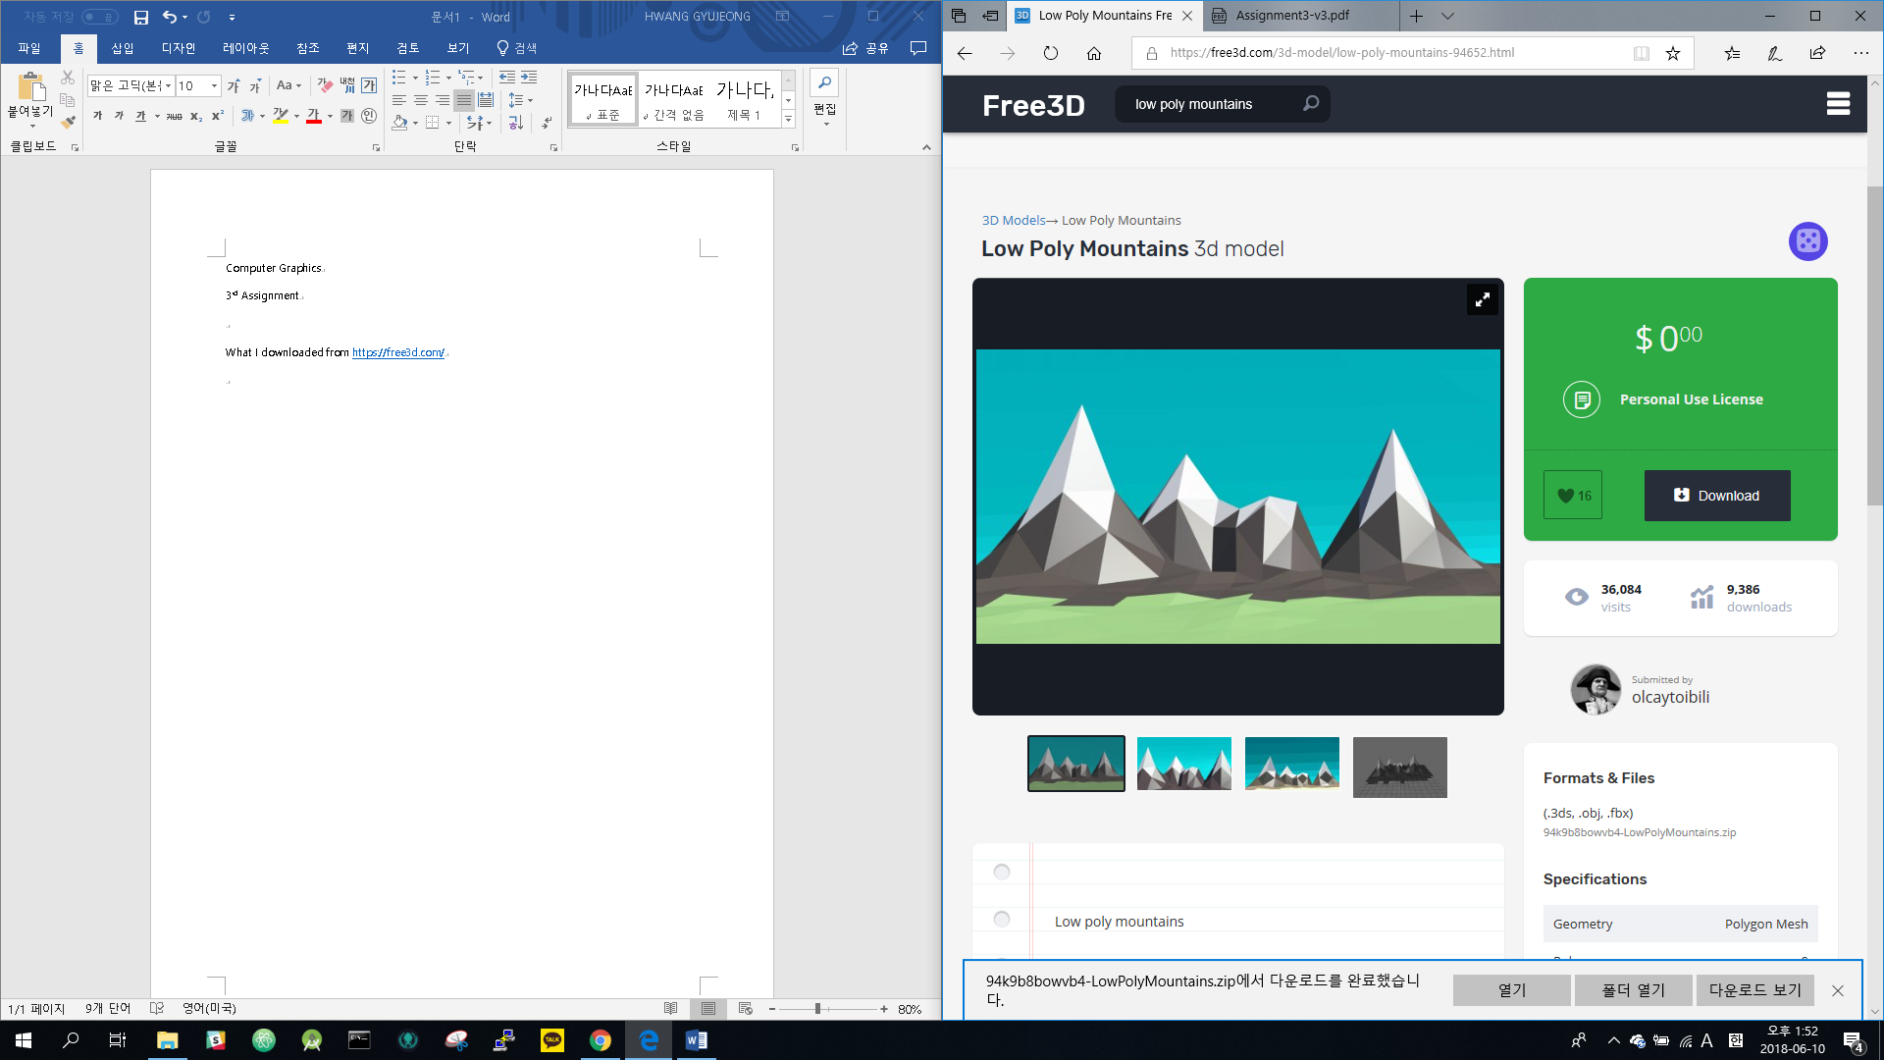

(<https://free3d.com/3d-model/low-poly-mountains-94652.html>)

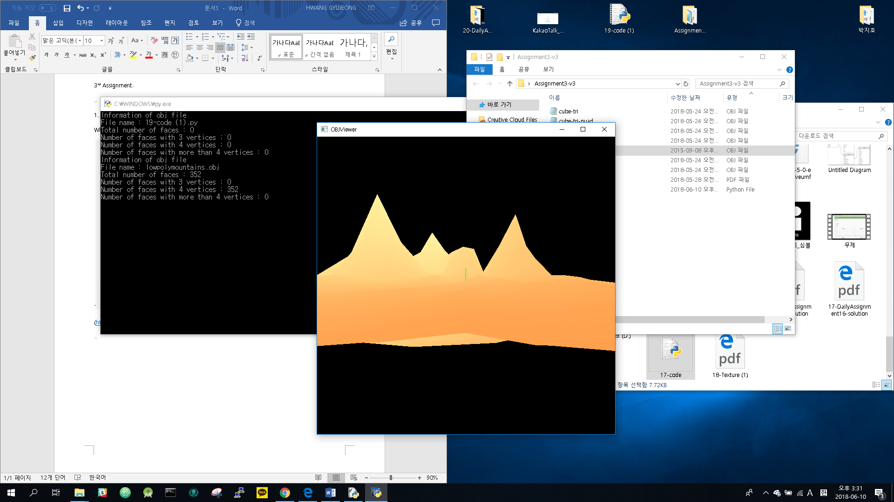(Light change as time flow)

Set the color in mind with the snow mountain in the sunset.

(Sorry for Google Translation)

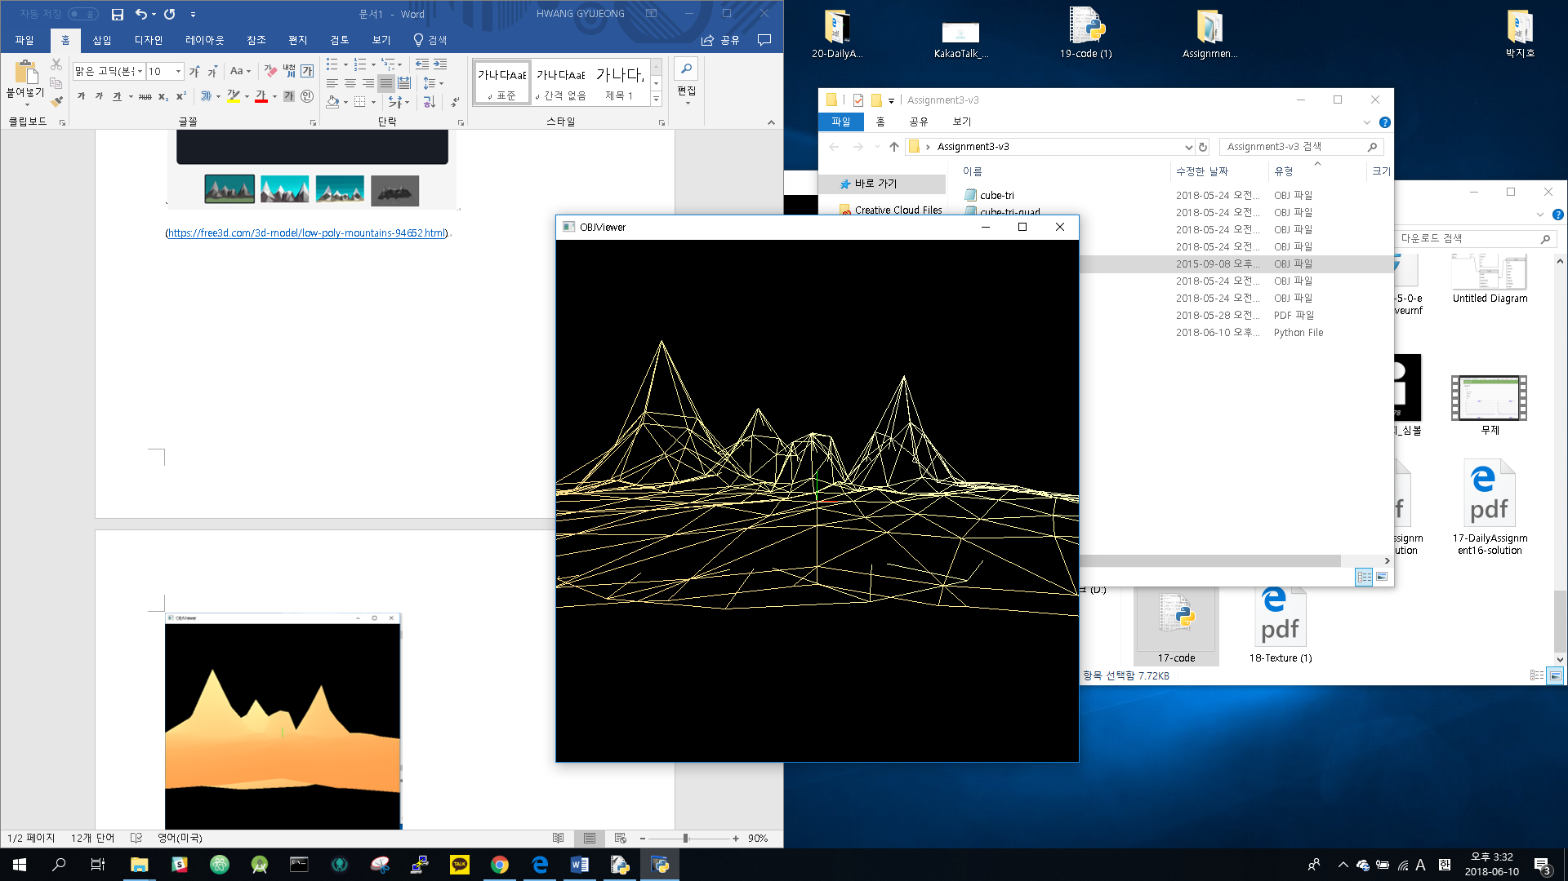(PRESS Z key)

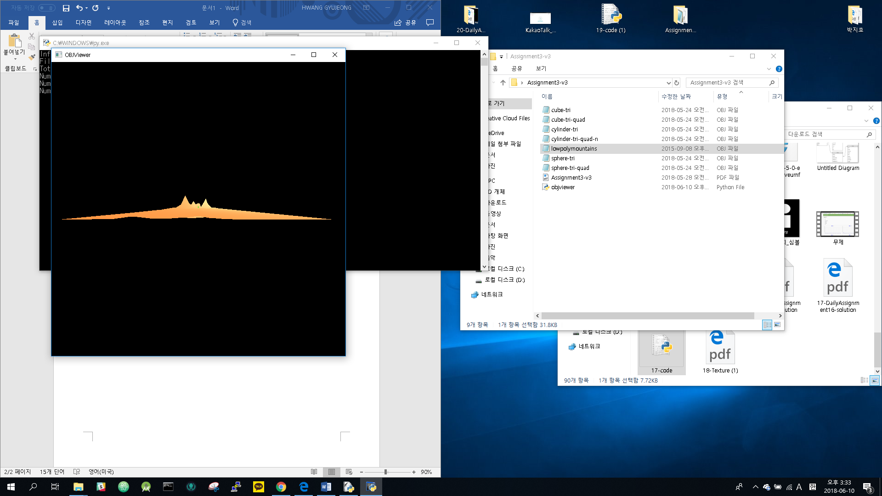(Overall image. It looks like stock chart)

2.

1.Just double click the OBJViewer.py file., and drag a obj file to the newly opend file.

2. I use triangulation algorithm, so n-polygons are translated to n-2 triangles. Also I use glDrawElements() to render a triangle mesh. I think, I fulfill the extra credit problems.